Ideation Phase
Empathize & Discover
Date | 20 FEB 2026
Team ID | LTVIP2026TMIDS78860
Project Name | Calculating Family Expenses using Service Now
Maximum Marks | 4

Empathize & Discover :
In the Empathize and Discover phase, the goal is to understand the real-life challenges families face in managing and tracking their monthly expenses. Many families struggle with budgeting due to scattered expense records, lack of automation, and poor visibility into spending habits. Through interviews, surveys, and observations, we gather insights into users’ pain points—such as difficulty in maintaining expense logs, confusion over recurring bills, and the need for a simple, automated system.
Using these insights, we identify key user needs like real-time tracking, categorization of expenses, automated reminders, and personalized reports. This phase helps define the foundation for designing a ServiceNow-based solution that simplifies expense management, enhances financial awareness, and supports informed decision-making for families.
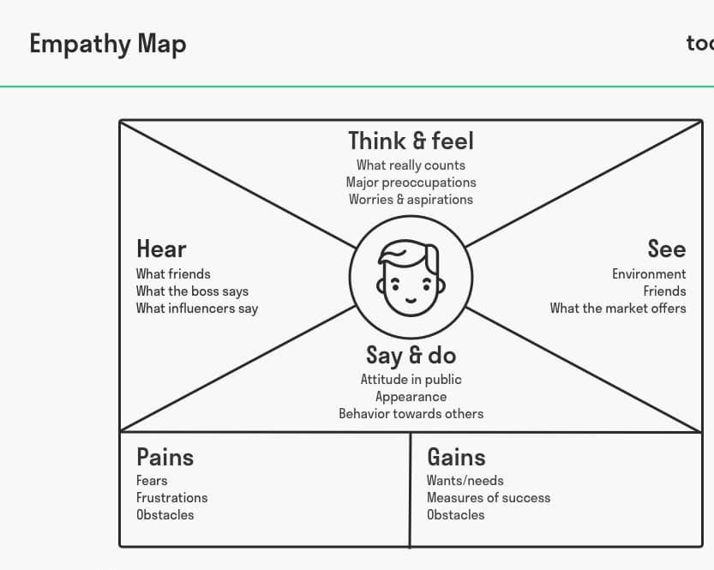

The “Calculating Family Expenses using ServiceNow” project focuses on simplifying and automating the process of managing personal and family finances. It empathizes with families, professionals, parents, and students who often face difficulties in tracking and analyzing their daily, weekly, and monthly expenses effectively.
Currently, many individuals rely on manual methods such as notebooks or spreadsheets, which are prone to errors, data loss, and inconsistency. Users often express frustration about not being able to identify where their money goes or realizing overspending too late. They also lack real-time insights and effective visualization of their spending patterns.
By integrating expense tracking into ServiceNow, this project aims to provide a smart and automated solution. The system enables users to record and categorize expenses easily, monitor budgets, and receive timely alerts. It also generates visual reports and summaries, offering users a clear view of their financial status and helping them make informed financial decisions.
In conclusion, the solution transforms traditional manual expense tracking into a
seamless, digital, and data-driven experience. With automation, real-time analytics, and secure storage, users gain better financial control, improved budgeting habits, and enhanced decision-making capabilities — ultimately promoting financial discipline and smarter family expense management.

